Engrafa Document Manager Mock API Challenge v1.0
Deployment Guide

Revision History
Author | Revision Number | Date
duxiaoyang | 1.0 | 3/7/2015

Deployment Instructions 3
1. Files changed in this challenge 3
2. Application Setup 3
2.1. Configuration file 3
3. Database Setup 3
4. Deployment Instructions 3
4.1. Install Gradle 3
4.2. Clone aws-mock application and apply the changes. 4
4.3. Start aws-mock application. 4
4.4. Update config.js. 4
4.5. Deploy and start document manager. 4
5. Verification 5
6. Resource Contact List 8

Deployment Instructions

Files changed in this challenge

Path | Description
document_manager/config.js | Add configurations for connecting to Mock API
document_manager/services/DocumentService.js | Add the option to connect to mock EC2 API.
aws-mock | Contains files updated for aws-mock project
aws-mock/src/main/java/com/tlswe/awsmock/ec2/  LoggingMockEc2Instance.java | A custom Mock EC2 instance which logs all status changes.
aws-mock/resouces/aws-mock-default.properties | Update to use the new LoggingMockEc2Instance

Application Setup

- Node.js 0.10.29 (http://nodejs.org/)
- MongoDB 2.6 (http://www.mongodb.org/)
- Box.com API (http://developer.box.com)
- Java JDK 1.6+
- Gradle 2+ (https://gradle.org/)

Configuration file
(Contains only new configuration. For complete list, please refer to original deployment guide located at document_manager/docs/DeploymentGuide.doc)

File config.js

Name | Description | Sample value
DOCUMENT_PROCESSOR_EC2_MOCK | This represents whether to use mock AWS API. | true of false
DOCUMENT_PROCESSOR_EC2_MOCK_ENDPOINT | This represents the endpoint of mock AWS API. It is used only if DOCUMENT_PROCESSOR_EC2_MOCK is true. | http://localhost:8000/aws-mock/ec2-endpoint/

Database Setup

Please refer to the original deployment guide for database setup.

Deployment Instructions

Install Gradle
Download Gradle from https://gradle.org/downloads and follow the Install Guide.

Clone aws-mock application and apply the changes.
Clone aws-mock from https://github.com/treelogic-swe/aws-mock.git. And then copy all files from aws-mock folder in this submission into the cloned repository (basically, there is only one new file LoggingMockEc2Instance.java and one changed file aws-mock-default.properties).

This has been done for you in the latest code base.

Start aws-mock application.
From the aws-mock directory, run:

$ gradle jettyRun

The application should start. Once the application is running, you should see similar output as below screenshot.

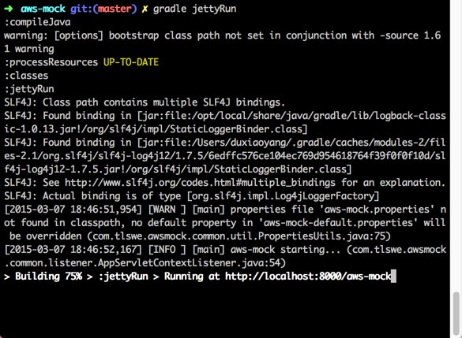

Update config.js.
Update config.js and set DOCUMENT_PROCESSOR_EC2_MOCK to true (it is false by default). You probably do not need to change DOCUMENT_PROCESSOR_EC2_MOCK_ENDPOINT. But if your aws-mock is running on a different port or context path, then you need to change it. You can find the value from the above screenshot, it is in the last line.

Deploy and start document manager.
Please follow the previous deployment guide 4.5 until 4.10. Since we are going to use mock API, so you don’t need document processer setting on AWS. And please don’t upload document yet. Besides, it’s recommended to start the app using “node worker.js” so you can see the console output directly.

Verification
After both aws-mock and document-manager are running, upload a document to input folder in box.com, and wait for a while. You will see the following log.

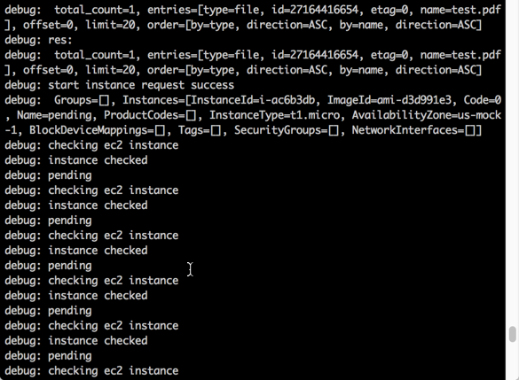

At the same time, the output from aws-mock is like this:

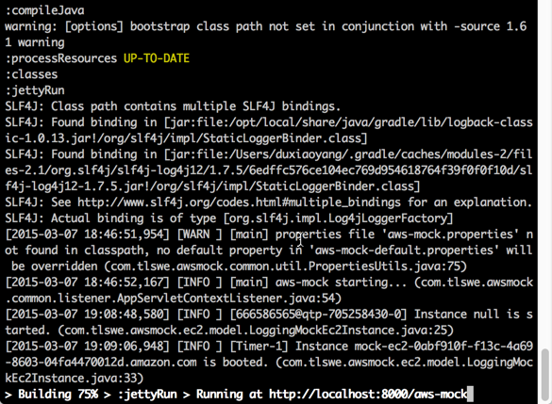

From the log files, we can see that document manager tries to launch an EC2 instance, and the request goes to Mock API. Then Mock API simply mocks the instance creation and eventually document manager is notified about the instance being successfully created (document manager needs to wait until the instance is created). Here we do not have any real EC2 instance launched, and also document processor is not even used.

Keep waiting for longer time, you will see the following log coming from document manager as well as aws-mock.
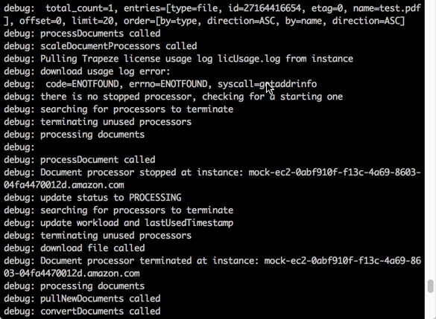

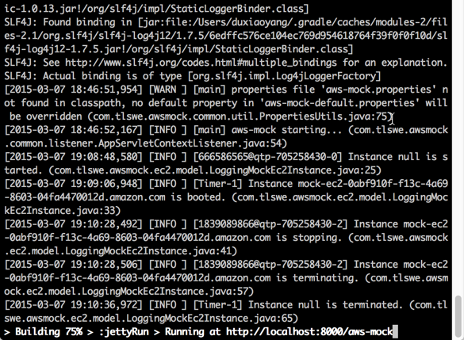

Because the instance is mock, it cannot process the document. So document manager tries to send the document to the instance for processing will fail, and the instance keeps idle. These logs indicate that after a certain period of idle time, document manager will try to stop and terminate the instance. The stop and terminate request will be sent to mock API and the API will return success response. Document manager will treat the instance as terminated and delete the record from database. Actually, you can check the database after instance is created and after instance is terminated. You will find out that there is record created once mock instance is created (even though there is no real instance) and the record is deleted once the mock instance is terminated.

Resource Contact List

Name | Resource Email
duxiaoyang | Use contact option from tc profile

